1. Create on Bash script to check if a directory is available or not.

#!/bin/bash : This is called a **shebang**. It tells the system to use the **Bash shell** to run the script.

echo "Enter the full path of the directory you want to check:"

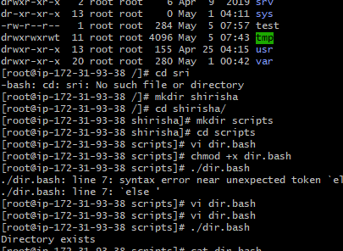

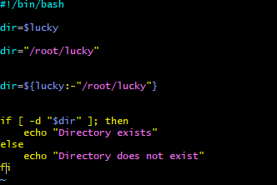

1. Create a bash script which will create multiple files. 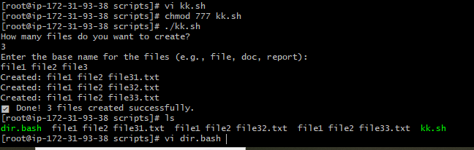

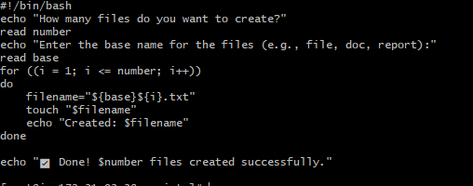

3) Create a bash script to take backup of a directory.

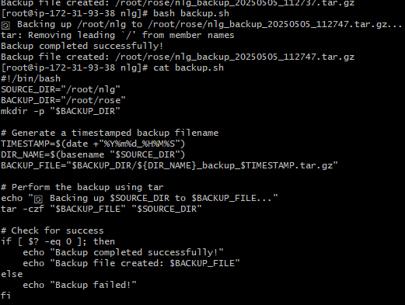

1. Create a bash script to install nginx in ec2 server. 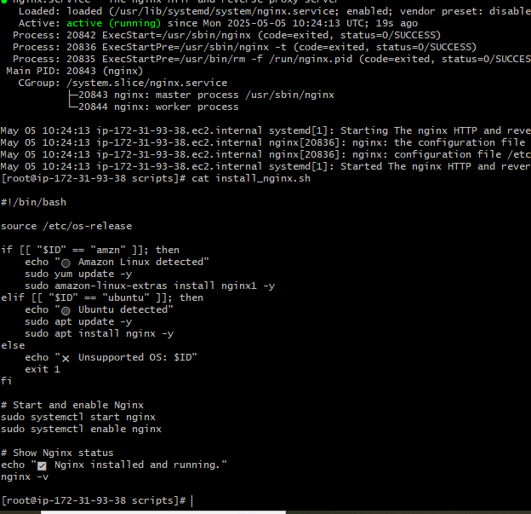
2. Create a bash script to install ApacheTomcat in ec2 serve

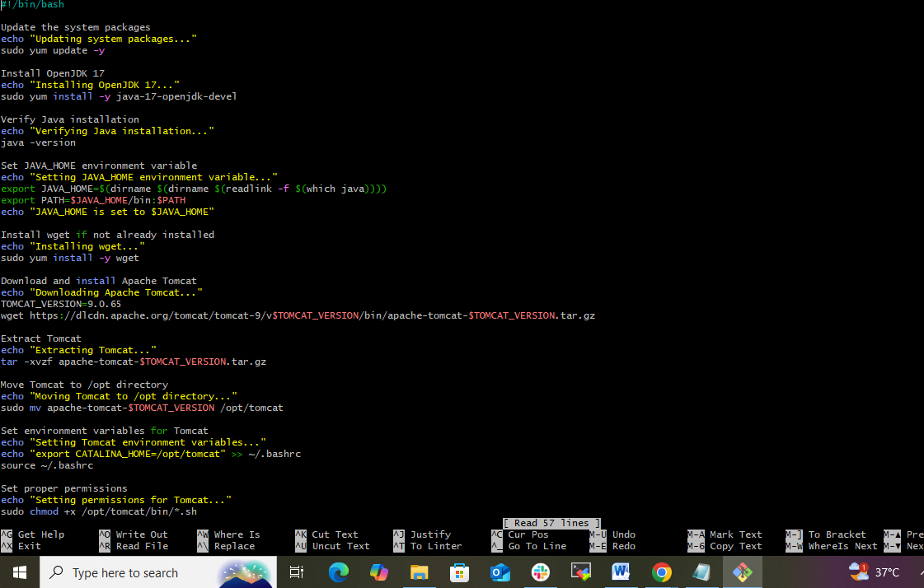

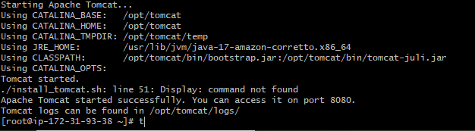

6) Create a bash script to check list if nginx service is running or not,if not running

then script should start the service.

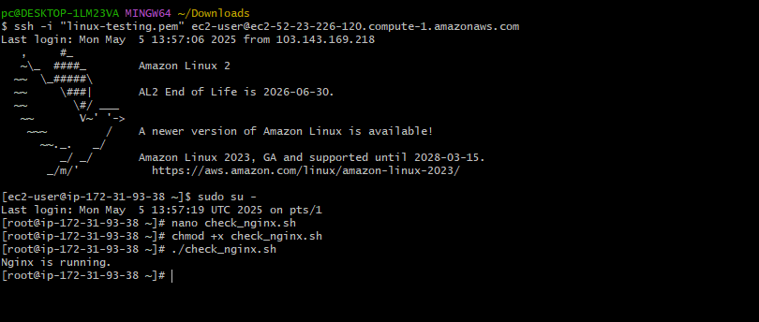

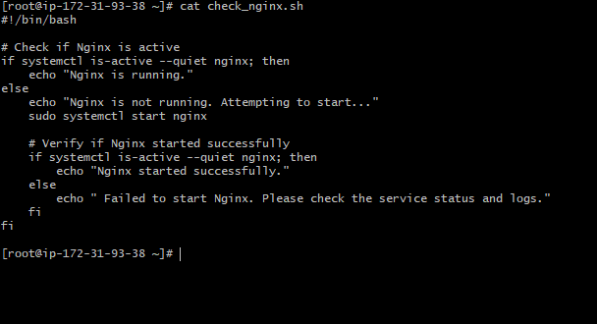

7) Create a bash script for calculator.

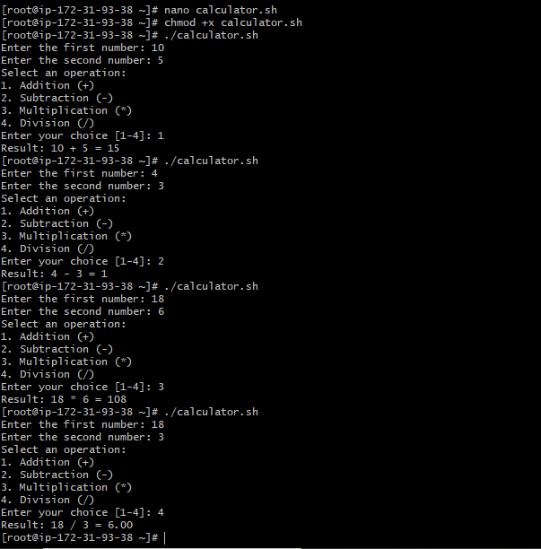

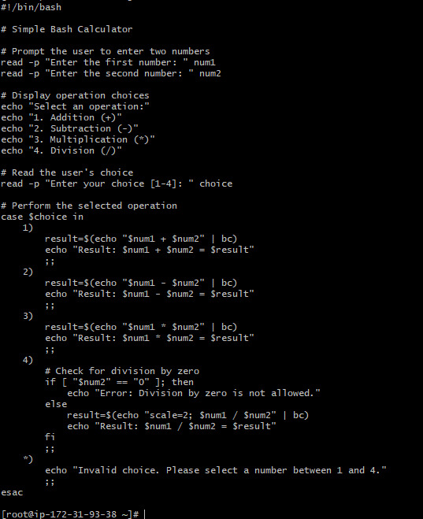

8) Create a bash script to check if directory is avaialble or not,if not then create a directory.

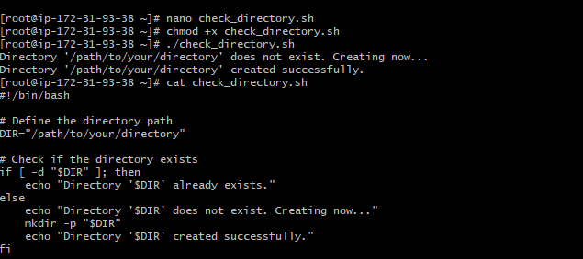

9) Create bash script to delete last 3 lines for a file.

